Assignment No. 03

Roll No. SC55 - Shreyas Chavhan

===================================================

# Calculator

## Problem Statement -

Write a C++ program create a calculator for an arithmetic operator (+, -, *, /). The program

should take two operands from user and performs the operation on those two operands

depending upon the operator entered by user. Use a switch statement to select the operation.

Finally, display the result.

Some sample interaction with the program might look like this:

Enter first number, operator, second number: 10 / 3

Answer = 3.333333

Do another (y/n)? y

Enter first number, operator, second number: 12 + 100

Answer = 112

Do another (y/n)? n

## Theory -

## Constructors are special class functions which perform initialization of every object. The Compiler calls the Constructor whenever an object is created. Constructors initialize values to object members after storage is allocated to the object.

## Whereas, Destructor on the other hand is used to destroy the class object.

## 

Types of Constructors in C++

## Constructors are of three types:

## Default Constructor -

Default Constructors

## Default constructor is the constructor which doesn't take any argument. It has no parameter.

Syntax:

class_name(parameter1, parameter2, …….){

// constructor definition

}

A default constructor is so important for initialization of object members, that even if we do not define a constructor explicitly, the compiler will provide a default constructor implicitly.

## 

1. Parameterized Constructor -

## These are the constructors with parameters. Using this Constructor you can provide different values to data members of different objects, by passing the appropriate values as argument.

1. Copy Constructor -

## These are special types of Constructors which takes an object as argument, and is used to copy values of data members of one object into another object

## Code -

|  |
| --- |
| /*******************************************************************************  Write a C++ program create a calculator for an arithmetic operator (+, -, *, /). The program  should take two operands from user and performs the operation on those two operands  depending upon the operator entered by user. Use a switch statement to select the operation.  Finally, display the result.  Some sample interaction with the program might look like this:  Enter first number, operator, second number: 10 / 3  Answer = 3.333333  Do another (y/n)? y  Enter first number, operator, second number: 12 + 100  Answer = 112  Do another (y/n)? n  *******************************************************************************/  #include<iostream>  using namespace std;  int main()  {  char c;  float n1,n2;  char ch;  do  {  cout<<"Enter first number, operator, second number::(Ex. 10 + 3): ";  cin>> n1 >> c >> n2;  switch (c)  {  case'+':  cout<<"Answer: " << n1+n2<<"\n";  break;  case'-':  cout<<"Answer: " << n1-n2<<"\n";  break;  case'*':  cout<<"Answer: " <<n1*n2<<"\n";  break;  case'/':  cout<<"Answer: " <<n1/n2<<"\n";  break;  default: cout<<"Enter a valid choice";  }  cout << "Do you want to continue: ";  cin >> ch;  }while(ch == 'y' || ch == 'Y');  return 0;  } |

Roll No. SC55 - Shreyas Chavhan

===================================================

## Output -

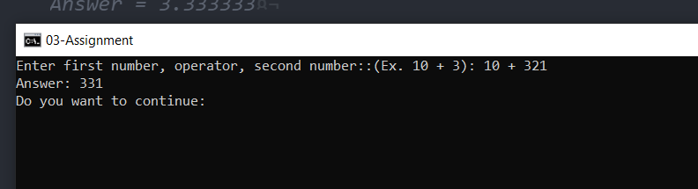

===================================================

Roll No. SC55 - Shreyas Chavhan